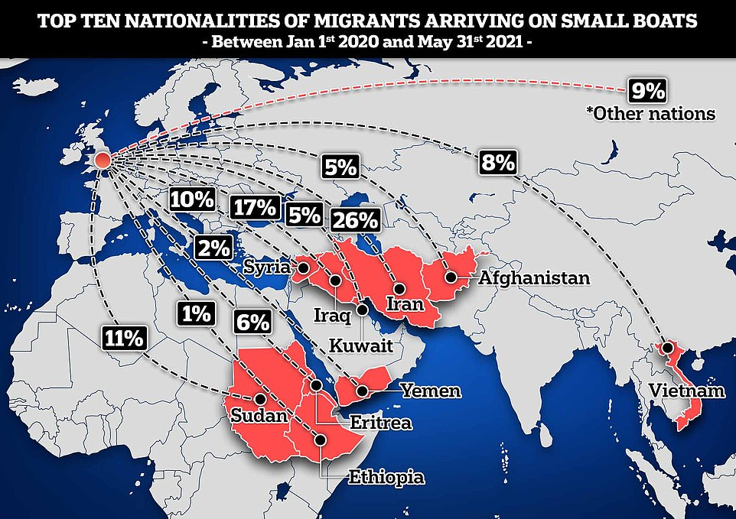

<https://www.dailymail.co.uk/news/article-10212177/Majority-Channel-migrants-Middle-East-report-British-Refugee-Council-finds.html>

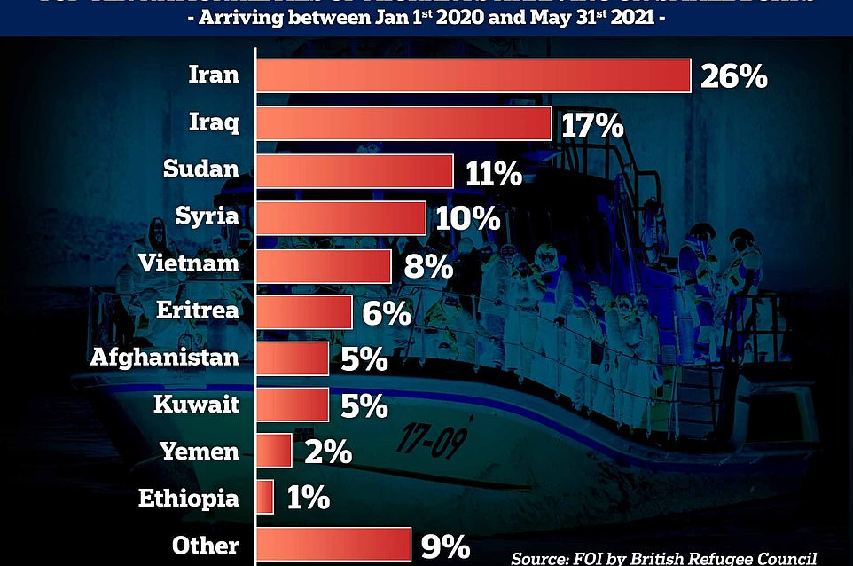

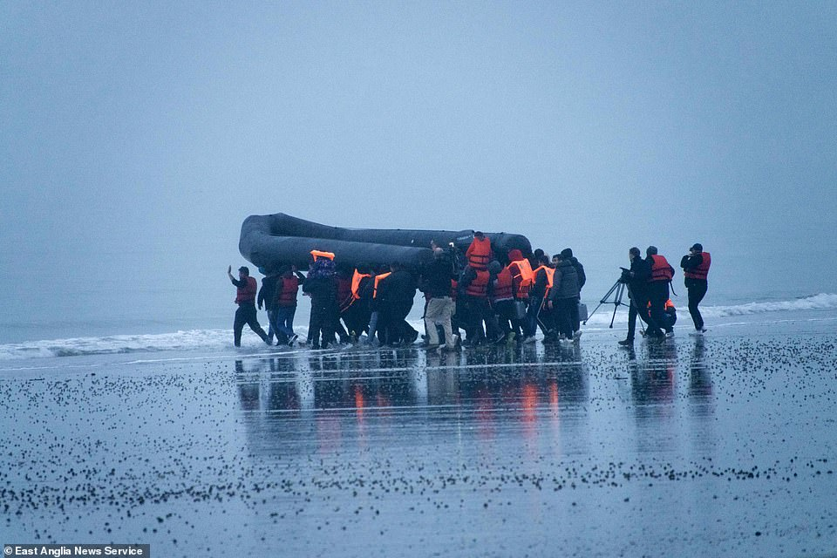

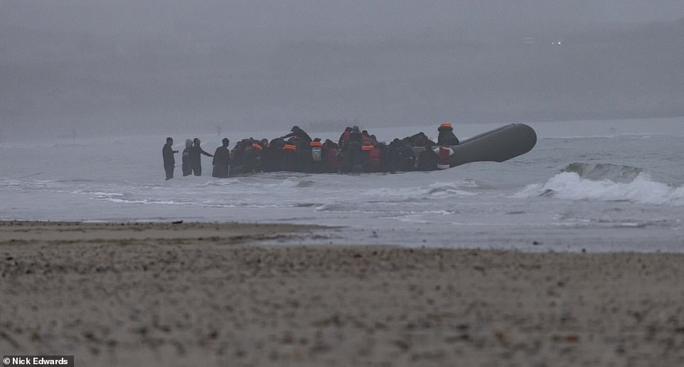

The migrants who had sent the night hiding in sand dunes were seen manhandling two huge 50ft long black inflatables down cliff tops to reach the sea

A loaded boat - with people smugglers pushing it from behind - heading into a choppy Channel towards Britain this morning

http://news.bbc.co.uk/2/shared/spl/hi/uk/05/born_abroad/html/overview.stm